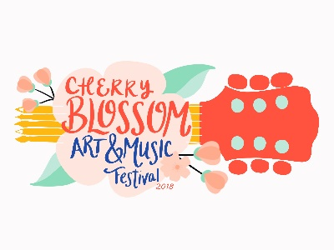
Cherry Blossom Art and Music Festival
in cooperation with SOKY Earth Day Festival
April 21, 2018
Artist Application

Name: ____________________________________________________________________________

Address: __________________________________________________________________________

Phone: _______________________________ Cell Phone: ________________________________

E-Mail Address: ____________________________________________________________________

Best way to contact you (circle one): Phone Text E-Mail Other __________________________

Do you have a studio? Yes No If so, where? __________________________________________________________________________________

Do you set up at shows/events/festivals? Yes No If so, list your most recent ones:

__________________________________________________________________________________

Please list the medium of artwork you wish to present at the Cherry Blossom Art Festival:

Describe how you plan to display your merchandise: _______________________________________

A key component of the Festival is for artists to demonstrate how they create their work, what will you be demonstrating? __________________________________________________________________________________

*Artist Fee: $25 Checks payable to Franklin-Simpson Renaissance

Festival Hours are 10:00 am to 2:00 pm Artist space is 10 x 10. A tent is not required but if using one, you must have a way to secure that does not involve stakes. Set up may begin at 8:30 am and must be completed by 10:00 am. Tear down may begin no sooner than 2:00 pm.

The number of artists will be limited. Artists are required to sell only the items listed on their application unless otherwise approved prior to the event time. Only items created by the artist will be permitted. No items containing nudity or profanity will be allowed. Festival organizers have the right to ask that items be removed from display if they do not meet Festival standards. We support our direct sales and independent consultants; however, we do not accept them at the Cherry Blossom Art and Music Festival. (Examples: Lularoe, Young Living, Mary Kay, etc).

